**User Management**

More users can be added to the account as the staff members to ease the handling of the business’s store. The added users have varying permissions according to the allotted roles. The merchant owns the store and has complete access over it, and he/she can decide the access of the staff members.

**Attention!** The users have higher privileges that you cannot be modified by you. You only have access to add/modify the users with lower privilege than yourself.

Other points are there too to be viewed about user management, they are:

* User Roles
* Create Users

**User Roles**

To access the system, the user must have been allotted some roles. User roles can be created by you or also by the IndoMarche platform itself. If you have the permission of creating the user roles, then you must also set the permissions for them.

SETTINGS >> USER ROLES

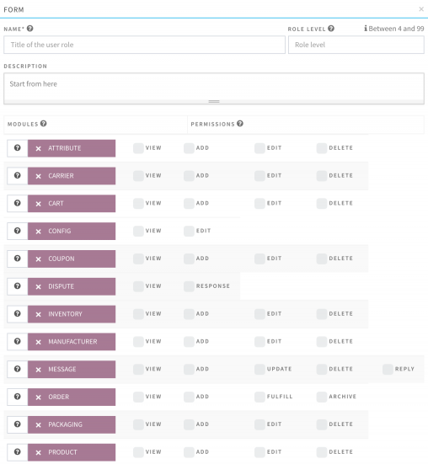

**Create Users**

Depending on your subscription package, you can also add the users to your account. Creating a user is pretty easy; you just need to provide some basic information about the user and save the changes. The user can then login and update his/her profile.

ADMIN>>USERS